Vehicle gates - outside

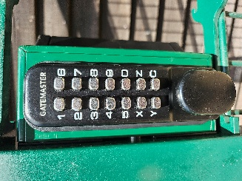
To open
1. Input the key code. Turn the handle clockwise.
2. Twist and raise the central rod on the left hand gate. Twist back so it doesn’t drop.
3. Open left hand gate fully to side of drive, push rod down to hold gate in place*.
4. Open other side, use rod to hold in place.
5. Drive through.
6. Close the gates behind you.

*If both rods have been dropped into the ground you will not be able to open the gate from the outside. Walk to one of the other gates and open the vehicle gate from the inside.

Note – the gates need to be secured while you are driving through as the wind can blow them closed. BWGC is not responsible for any damage to your vehicle caused by failure to secure the gates.

Gates should be closed at all times except on weekends when The Shop is open.

Vehicle gates - outside

To close
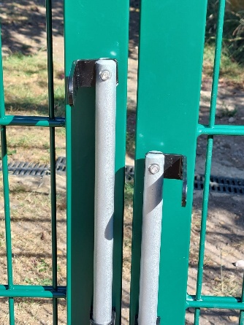
1. Start at right gate. Twist the rod, lift and twist back.

2. Close gate, drop rod into hole in ground.

3. Left gate - twist rod, lift and twist back.

4. Pull gate shut – DO NOT drop rod into hole. The rods should remain at different heights – see picture.

5. Make sure the central rod is firmly pushed into the hole and the gates are securely closed.

Gates should be closed at all times except on weekends when The Shop is open.

